**Importance Ranking Calum**

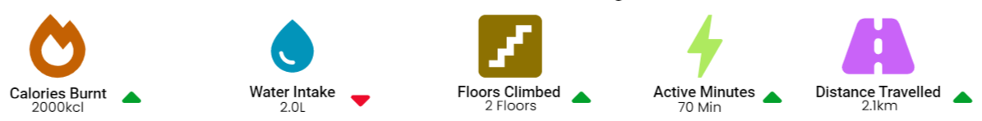

**Description**

These Icons are the data being displayed on the catchup page feeding in from the clients FitBit Live.

**Ranking**: 9 / 10

**Comments**: Would put steps up instead of distance travelled

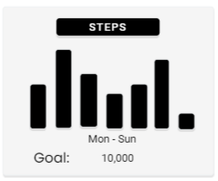

**Description**

This graph displays the clients steps from the week with regard the goal set for them by their Trainer

**Ranking**: 7 / 10

**Comments**: No need for a graph in my opinion, but still very useful information

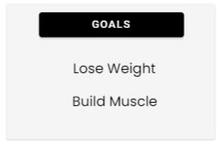

**Description**

These are the clients goals set for the trainer by the client, these are used to show the trainer what the client wants

**Ranking**: 7 / 10

**Comments**: Don’t need a constant reminder but good if clients goal changes, could that be shown with an update icon

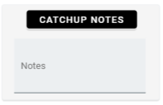

**Description**

This area is used to input the trainers thoughts at the end of a catchup meeting, to serve as a reminder when they are on the manage page. The notes are visible on the manage page.

**Ranking**: 8 / 10

**Comments**: Good for use on manage page

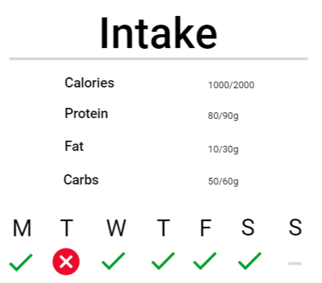

**Description**

This is the clients intake compared to the goals set by the trainer. The week icons on bottom show whether or not the client reached the target.

**Ranking**: 8 / 10

**Comments**: Very useful information, I like the weekly checks

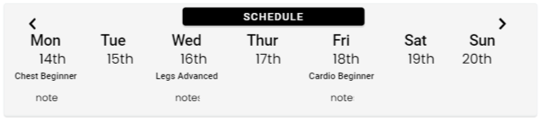

**Description**

This shows the clients workout schedules, set by the trainer. The schedule also contains any feedback the client input at the end of a workout for the trainers viewing

**Ranking**: 9 / 10

**Comments**: Very good, use of clients notes very good feature, would use that a lot before the catchup meeting

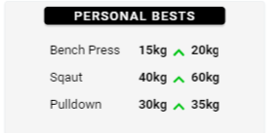

**Description**

This shows the clients personal best for any exercise they are improving with, the weight is input by the client

**Ranking**: 7 / 10

**Comments**: Might not be relevant regarding certain clients

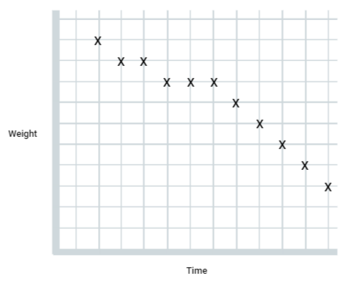

**Description**

This graph displays the clients weight progression over their time with the personal trainer

**Ranking**: 7 / 10

**Comments**: Good feature but might not be relevant as client may not be losing weight if they are losing fat and building muscle

[Link to UI for Use](https://app.uizard.io/p/74877f9d)